PRACTICAL NO.06

SUBMITTED BY:-

RAGAV SHARMA

PARTH KITCHLOO

POLYMORPHISM IN JAVA

Introduction to Polymorphism
Polymorphism is one of the main concepts of Object-Oriented Programming (OOP) in Java.
The word Polymorphism is derived from:
- Poly → Many
- Morph → Forms
👉 So, Polymorphism means "one name, many forms".
In Java, polymorphism allows a method, object, or operator to perform different actions depending on the situation.

Types of Polymorphism in Java
Java supports two types of polymorphism:
1 Compile-Time Polymorphism (Static Polymorphism)
2 Run-Time Polymorphism (Dynamic Polymorphism)

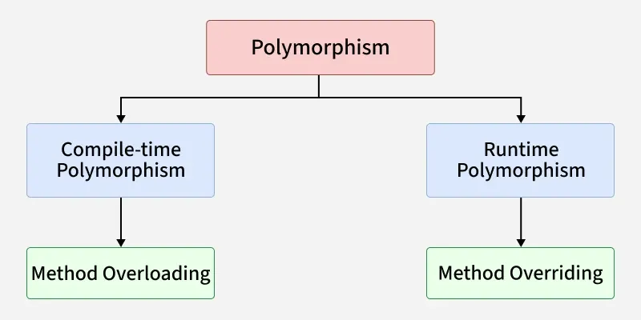
1. Compile-Time Polymorphism (Method Overloading)
2. Runtime Polymorphism (Method Overriding)

Compile-Time Polymorphism
Also called Method Overloading.
Achieved when multiple methods have the same name but different parameters.
Decision is made at compile time.

Method Overloading Rules
- Method name must be same.
- Parameters must be different (number or type).
- Return type alone cannot differentiate methods.

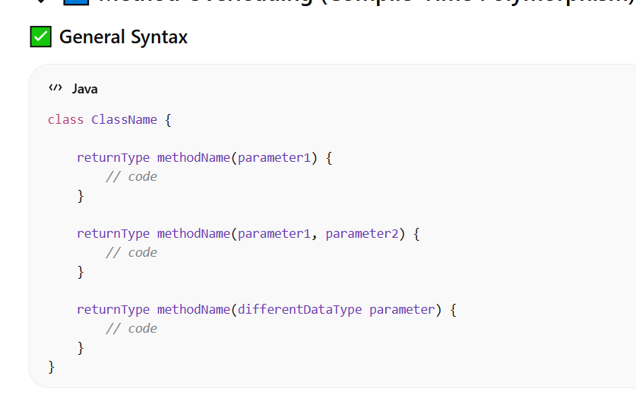

Run-Time Polymorphism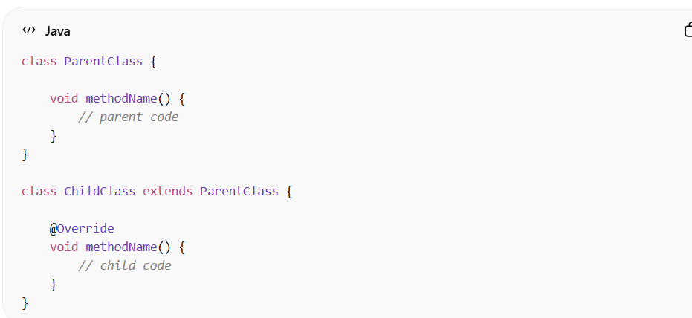
Also called Method Overriding.
Achieved through Inheritance.
Method call is decided at runtime.
Based on object type, not reference type.

Rules for Method Overriding
- Same method name.
- Same parameters.
- Must be in parent and child class.
- Access modifier cannot be more restrictive.
- Cannot override static or final methods.

Dynamic Method Dispatch
Dynamic method dispatch is the mechanism by which:
A call to an overridden method
Is resolved at runtime
Based on object type

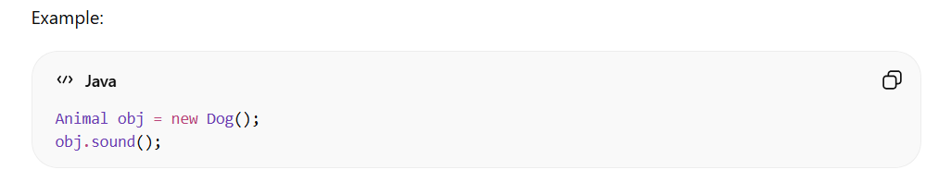
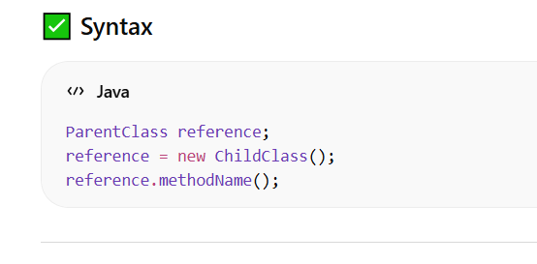
Even though reference is Animal, the object is Dog, so Dog method is executed.

Overloading vs Overriding
Feature | Overloading | Overriding
Class | Same class | Parent & Child
Parameters | Must differ | Must be same
Binding | Compile time | Runtime
Inheritance | Not required | Required
Keyword | No special keyword | @Override recommended

Advantages of Polymorphism
Code reusability
Flexibility
Extensibility
Improves readability
Supports dynamic binding

Real Life Example
Think of a Remote Control:
- One button → Different functions (TV, AC, Fan)
- Same interface → Different behavior
That is polymorphism.

Disadvantages of Polymorphism
- Slight performance overhead
- Harder debugging
- Can increase complexity if misuse

Upcasting and Downcasting

Upcasting
When a child class object is referred by parent class reference.
It is:
- Automatic
- Safe
- Used in runtime polymorphism
Example:
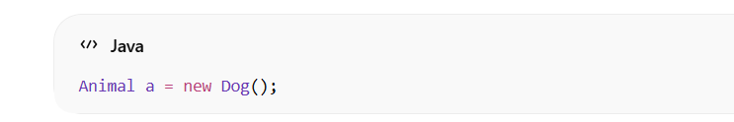

Downcasting
When parent reference is converted into child reference.
It is:
- Explicit
- Risky if wrong type
- Used to access child-specific methods
Example:
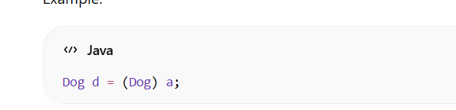

instance of Operator
Used to check object type before downcasting.
It prevents:
ClassCastException
Example:
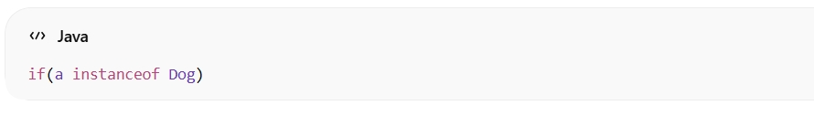

Polymorphism with Interfaces
Java also supports runtime polymorphism using interfaces.
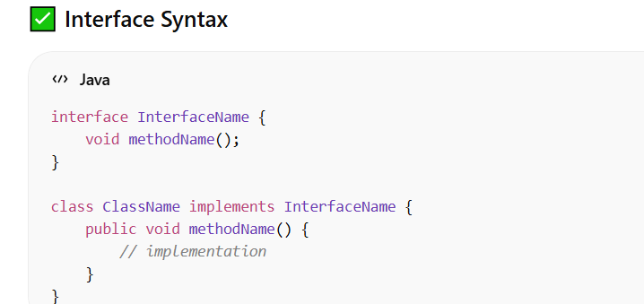

Polymorphism with Abstract Class

Abstract Class Syntax
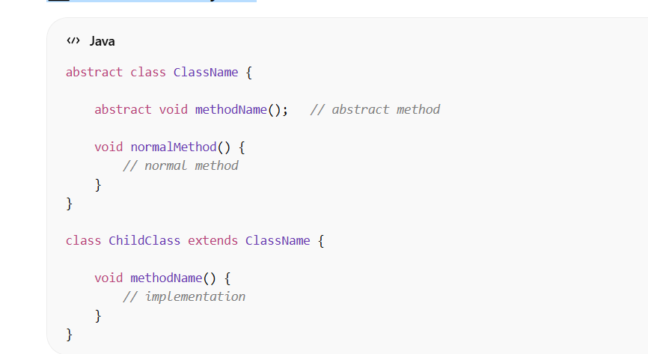

Static Binding vs Dynamic Binding
Feature | Static Binding | Dynamic Binding
Time | Compile Time | Runtime
Type | Overloading | Overriding
Speed | Faster | Slightly slower
Inheritance | Not required | Required

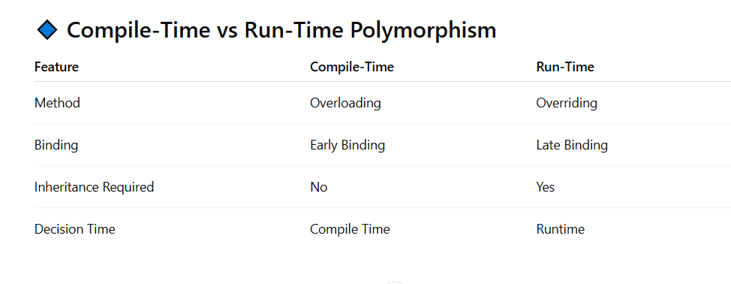

Key Points
- Polymorphism improves program flexibility.
- Overloading → Same class.
- Overriding → Parent & Child class.
- Achieved using inheritance and interfaces.

Conclusion
Polymorphism is a powerful OOP concept that allows:
Same method name
Different implementations
Flexible code design
Runtime decision making
It is widely used in:
- Enterprise applications
- Frameworks (Spring, Hibernate)
- GUI applications
- Banking systems
- Game development

